TrianglesAndRectanglesOhMy
In this problem you will implement five (5) methods dealing with the properties of triangles and rectangles.
The first method to implement is getNumPossibleTriangle. Given three arrays of ints, how many different ways is it possible to pick 1 number from each array, so that the three numbers could be the lengths of the three sides of a triangle.

According to Wikipedia:
In mathematics, the triangle inequality states that for any triangle, the sum of the lengths of any two sides must be greater than the length of the remaining side.
The following clarification is from mathhouse.com:
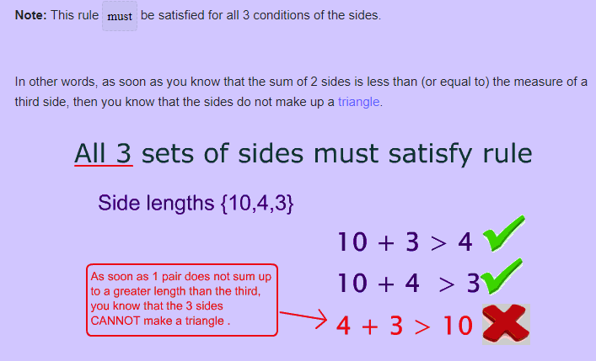

For example, given int[]:
side1 = {1, 2, 3} side2 = {3, 4, 5} side3 = {5, 6, 7}
Ten different Triangles can be made by choosing one value from each array. The 10 possible triangles would have sides of length:
- {1, 5, 5}
- {2, 4, 5}
- {2, 5, 5}
- {2, 5, 6}
- {3, 3, 5}
- {3, 4, 5}
- {3, 4, 6}
- {3, 5, 5}
- {3, 5, 6}
- {3, 5, 7}

The following code shows the results of the getNumPossibleTriangle method.
The following code | Returns
int[] side1 = {1, 2, 3};
int[] side2 = {3, 4, 5};
int[] side3 = {5, 6, 7};
TrianglesAndRectanglesOhMy.getNumPossibleTriangle(side1,  side2, side3); | 10

Another example: given int[]:
side1a = {2, 4, 4} side2a = {1, 3, 1} side3a = {5, 2}
Seven different Triangles can be made by choosing one value from each array. The 7 possible triangles would have sides of length:
- {2, 1, 2}
- {2, 3, 2}
- {2, 1, 2} - since side2 contains the value 1 twice, this triangle will get counted twice
- {4, 3, 5}
- {4, 3, 2}
- {4, 3, 2}
- {4, 1, 2}

And, the following code shows the results of the getNumPossibleTriangle method.
The following code | Returns
int[] side1a = {2, 4, 4};
int[] side2a = {1, 3, 1};
int[] side3a = {5, 2};
TrianglesAndRectanglesOhMy.getNumPossibleTriangle(side1a,  side2a, side3a)); | 7

The second and third methods to be implemented are the possibleMinThirdSideOfTriangle and possibleMaxThirdSideOfTriangle. Both methods have three parameters. The first two parameters are two sides of a triangle and the third parameter is an array of ints. The possibleMinThirdSideOfTriangle returns the smallest value from the int array that can be the third side of the triangle, and possibleMaxThirdSideOfTriangle returns the largest value from the int array that can be the third side of the triangle.

For example, given the two sides 7 and 19 and the array containing the values: 13, 6, 9, 37, 11, 5, 2, 23, 17. 13 is the smallest value in the array that forms a triangle along with sides 7 and 19. And 23 is the largest value in the array that forms a triangle with sides 7 and 19.

And, the following code shows the results of the possibleMinThirdSideOfTriangle method.
The following code | Returns
int[] possibleSides = {13, 6, 9, 37, 11, 5, 2, 23, 17};
TrianglesAndRectanglesOhMy.possibleMinThirdSideOfTriangle(7, 19,  possibleSides); | 13

And, the following code shows the results of the possibleMaxThirdSideOfTriangle method.
The following code | Returns
int[] possibleSides = {13, 6, 9, 37, 11, 5, 2, 23, 17};
TrianglesAndRectanglesOhMy.possibleMaxThirdSideOfTriangle(7, 19,  possibleSides) | 23

The final two methods in this problem concern properties of rectangles. The first method is the getNumPossibleRectangleWithArea. This method has three parameters; the first two parameters are arrays of int containing possible lengths of the sides of a rectangle. The third parameter is an int representing the desired area of the rectangle. This method returns the number of rectangles that can be formed by choosing one value from each of the two int array parameters such that the area of this rectangle is equal to the third parameter (the desired area of the rectangle).

For example, given int[] and a desired area of 24:
sideA = {2, 4, 8, 11} sideB = {1, 3, 6, 7, 8}
Two different rectangles can be made by choosing one value from each array.
- 4 from first array and 6 from second array
- 8 from first array and 3 from second array

The following code shows the results of the getNumPossibleRectangleWithArea method.
The following code | Returns
int[] sideA = {2, 4, 8, 11};
int[] sideB = {1, 3, 6, 7, 8};
TrianglesAndRectanglesOhMy.getNumPossibleRectangleWithArea(sideA,  sideB, 24) | 2

And in another example, given int[]and a desired area of 24:
sideA1 = {2, 4, 8, 2, 11} sideB1 = {12, 6, 3, 7, 8}
Four different rectangles can be made by choosing one value from each array.
- 2 from first array and 12 from second array
- 4 from first array and 6 from second array
- 8 from first array and 3 from second array
- 2 from first array and 12 from second array

And, the following code shows the results of the getNumPossibleRectangleWithArea method.
The following code | Returns
int[] sideA1 = {2, 4, 8, 2, 11};
int[] sideB1 = {12, 6, 3, 7, 8};
TrianglesAndRectanglesOhMy.getNumPossibleRectangleWithArea(sideA1,  sideB1, 24) | 4

The final method in this problem is the rectangleWithAreaAndMinPerimeter. This method has the same three parameters as getNumPossibleRectangleWithArea: the first two parameters are arrays of int containing possible lengths of the sides of a rectangle. The third parameter is an int representing the desired area of the rectangle. This method returns the an int[] containing two values. The two values are the sides of rectangles that can be formed by choosing one value from each of the two int array parameter such that the area of this rectangle is equal to the third parameter (the desired area of the rectangle) with the minimum Perimeter. The value from the first parameter is stored in the first element (index == 0) and the value from the second parameter is second element (index == 1) of the array being returned.

Example continues on next page

For example, given int[]and a desired area of 24:
sideA1 = {2, 4, 8, 2, 11} sideB1 = {12, 6, 3, 7, 8}
Two different rectangles can be made by choosing one value from each array.
- 4 from first array and 6 from second array
- 8 from first array and 3 from second array

The perimeter of the first triangle is 2*4+2*6 = 20 and the perimeter of the second triangle is 2*8+2*3 = 22 so an array of length 2 with a 4 in index 0 and 6 in index 1 is returned.
You may assume getNumPossibleRectangleWithArea(sideA1, sideB1, area) > 0

The following code shows the results of the rectangleWithAreaAndMinPerimeter method.
The following code | Returns
int[] sideA1 = {2, 4, 8, 2, 11};
int[] sideB1 = {12, 6, 3, 7, 8};
int[] stu =
TrianglesAndRectanglesOhMy.rectangleWithAreaAndMinPerimeter(
sideA1, sideB1, 24);
stu[0] | 4
stu[1]; | 6

